Assessment type (þ):
☐ Questioning (Oral/Written)
☐ Practical Demonstration
☐ 3rd Party Report
☒ Other – Lab

Assessment Resources:
The base requirements this assessment task include:
- IDE or editor for developing Python programs (only IDLE and PyCharm supported by the college)
- Access to Office 365 & Microsoft Word
- Virtual machine
You may not need all these for every part in this assessment

Assessment Due:
This assessment is due after the weekly session, Week 6, Friday 17:00.

Assessment Instructions:
- Your code must be written in IDLE or PyCharm IDEs. If you are using a different IDEs or a different structure for your application, then assistance from your lecturers may be limited (at best).
Discuss with your lecturer before straying too far off the path!
- All resources used should be referenced with the question. Answers may not be copied and pasted from any resource. All answers must be reworded to display your understanding.
- You may only use Python functionality, methods and libraries which were taught in this unit.
- First line of code in a program should have the student’s name and number, as proof of authenticity.
- Screenshots of all programs must be included in this document, with the appropriate question.
- Screenshots of testing, showing your code works as intended, should be included with the relevant question.
- Python programs should be named: XXX_Lab##_SYY_QZZ
Replace XXX with your initials
Replace ## with Lab number
Replace YY with Section number,
Replace ZZ with Question number
- It is a submission requirement that all screen shots be signed in some way. Some acceptable examples of signed screen shots are shown below.
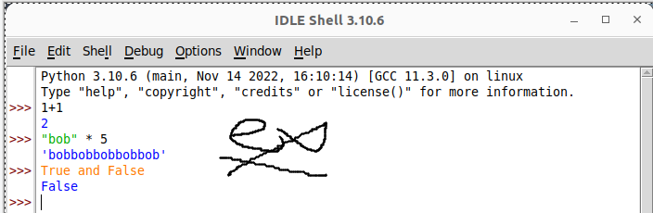
Example 1: Signed using a simple drawing tool.
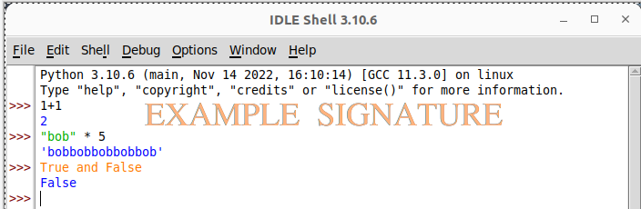
Example 2: Water marked signature.
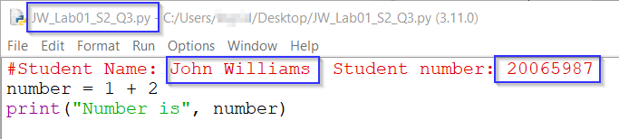
Example 3: Program named as prescribed, as well as first line comment with student name and number. Program saved as pre-described.
- All python programs must be included in the submission, as well as this document.

Assessment Instrument:

Section 1: Sequences in strings
Run the following comparisons in the shell/interpreter.
Code | Screenshot
quote = “Pull yourself together, Gary! We need you now more than ever!”
quote[0] | 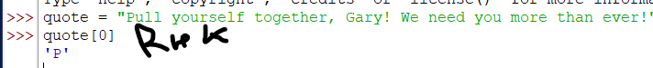
quote[0:10] | 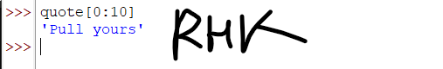
quote[1:] | 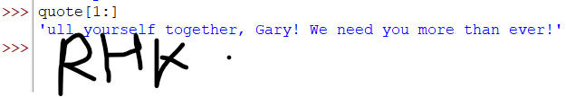
quote[-1] | 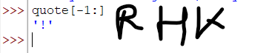
- Can you change any of the characters in any position of an existing string?
No, because strings are immutable in Pyhton

Section 2: Working with strings
Frequently in Python, you will be required to work with string comparisons or determining if a condition exists based on a string. Complete the following tasks in the Python shell/interpreter.
- Run the following string operations and evaluate the output:
Code | Screenshot
“a” in “awesome” | 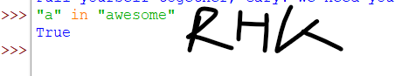
“A” in “awesome” | 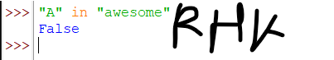
“word” == “word” | 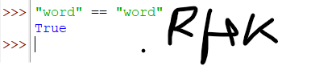
“Word” == “word” | 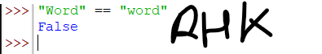
“word” == “word” and “pie” == “pie” | 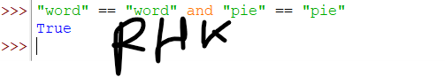

Section 3: String methods
There are many things you can do with a string. Complete the following tasks in the Python shell/interpreter using string methods.
Code | Screenshot
- Run the following code and evaluate the output: | 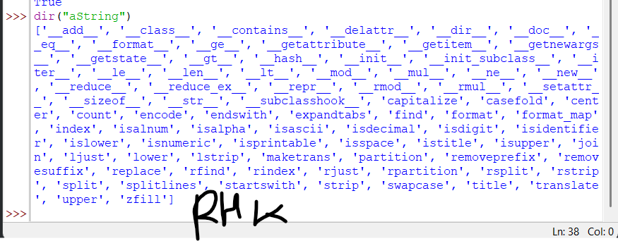
- Using the output of the above command, find, execute, and provide screen shots of the appropriate string methods for each of the following tasks:
Code | Screenshot of code and output
- Change a string to all capital letters. | 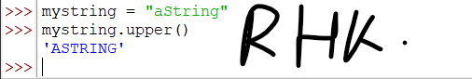
- Change a string to all lower-case letters | 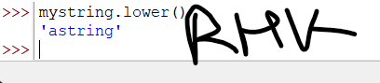
- Check if a string is blank (only made of white space). Two possible outcomes so a screen shot showing each | 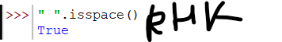  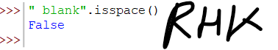
- Count all the occurrences of a particular character in a string. | 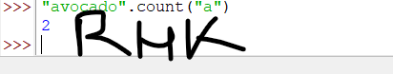
- Remove the white space at the end of a string (example, “ Bob ”). | 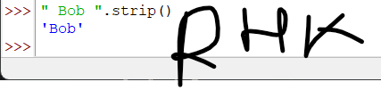
- Find the starting index of the substring ‘ox’, the substring ‘mpd’ and the substring ‘zy d’ in the string “The quick brown fox jumped over the lazy dogs” | 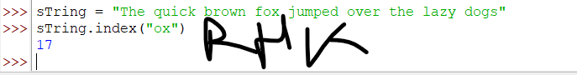  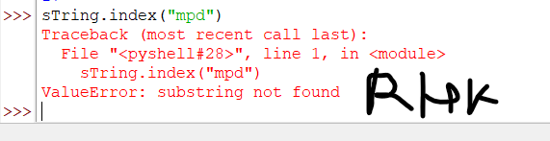  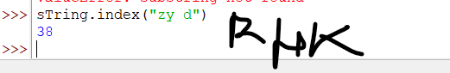
- Determine if a string is made of digits. Two possible outcomes so a screen shot showing each | 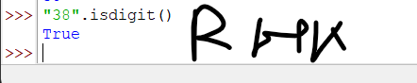  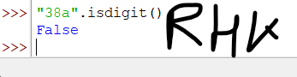

Section 4: Pseudocode review
Identify at least two examples of invalid pseudocode in the sample provided. Explain why it is not valid
- import random, math
- Generate a random integer between 5 and 10
- Ask the user to enter a string of letters of the alphabet, with as many letters as the randomly generated number.
- Convert the string to all lowercase letters
- For each letter in string:
  - ascii value = letter.ord
  - Add the ASCII value of letter to the total
- total = total/10
- Dim num1 As integer
- num1 = Math.floor(total)
- tell the user that they have 5 guesses to guess a number between 48 and 122.
- guesses = 0
- While the user has had less than 5 guesses
  - input(please input your guess)
  - If their guess is equal to ‘num1’
    - Output message telling them they guessed correctly
    - System.exit
  - Otherwise if guess is less that ‘num1’
    - println(“ the number is higher”)
  - Otherwise
    - puts “ the number is lower”
  - End If
  - guesses equals guesses plus one
- End while
- Output that they have used all their guesses and show ‘num1’
- End if

Issue 1:
- Dim num1 As integer
Here DIM is a keyword from a particular programming language but pseudocode should be independent of any particular programming language
Issue 2:
- num1 = Math.floor(total)
Instead of using the calculation it could be written as a generic statement

Section 5: A challenge
Complete the following challenge by writing pseudocode, creating code, and demonstrating its functionality.
You are required to create a script that will ask a user to input five words and tell the user which of those words has the most letters. The prompt for the user input must be of the format:
Enter word 1 of 5:
The word number increases each time a valid input is entered
For the purposes of this challenge a word is defined as a collection of characters, not actual words from any language. Only words that do not contain white space or hyphens are allowed. All other characters are permissible.
Where there is more than one word with the most letters it is acceptable if your code only identifies one of them

Begin the challenge by writing a basic algorithm (pseudocode) to meet the requirements.

Further develop your algorithm pseudocode to demonstrate how your algorithm will function. Your pseudocode must:
Contain at least one loop.
Contain at least one “if” statement.
Account for all situations by handling any invalid input by the user.
Complete your solution by translating your pseudocode into Python code.
Note: To be marked as satisfactory for this task, your solution must:
Produce and submit your pseudocode.
Demonstrate through screen shots, that your solution addresses all the above points.
You must submit the code file with this document.
Contain comprehensive commenting – one comment per line

Screenshot of pseudocode
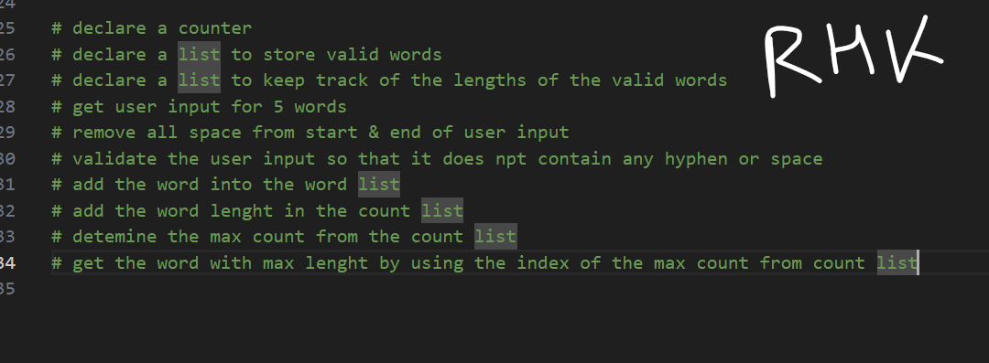

Screenshot of output:
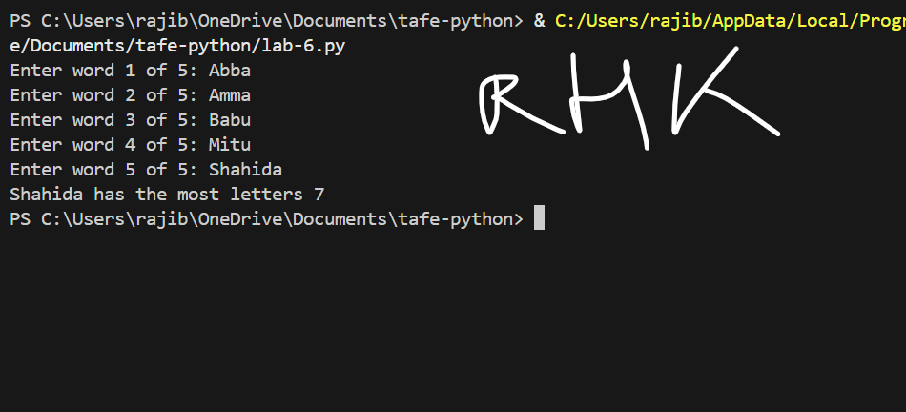
Screenshot of code:
